04/02/2026: in the PL room :
- Basics of a Photoluminescence setup (here, Hyperspectral imaging « PL cube » $I_{PL}(x,y,λ$) in continuous regime (continuous laser) )
- Laser alignement
- PL acquisition (software PhySpec)
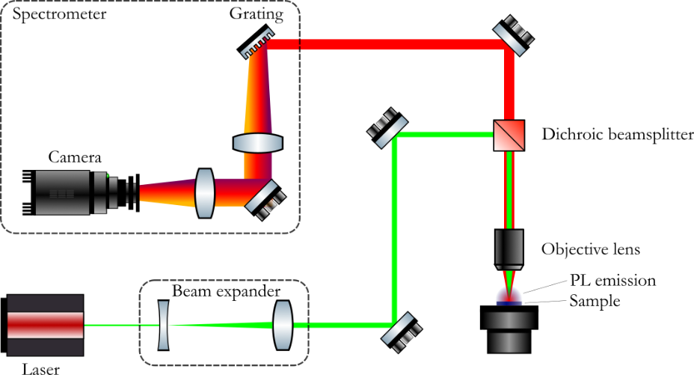

More precisely : objective lens : Nikon 50x 0.60 NA
Filters : BSW 26% Reflection + FELH 550nm
Laser : CW 532 nm
+ absolute calibration lamp (Bentham lamp) spectra in photon number (and not arbitrarily camera counts)

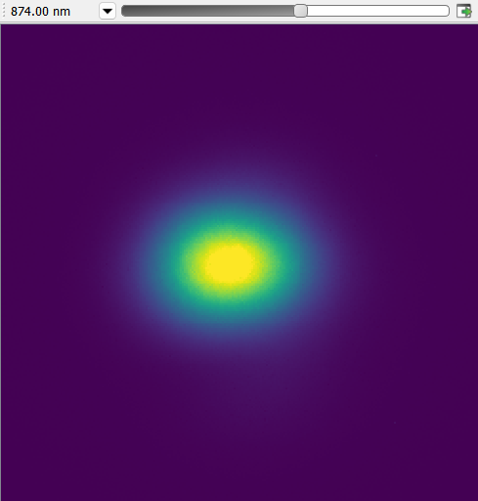
11/02/2026 : analysis of PL data
PL cube :
$$I_{PL}(λ, x, y)$$

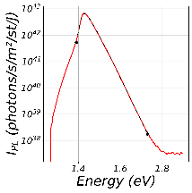

We only look at the few pixels in the center of the excitation spot.

How do we extract information on hot carriers from a PL spectrum ?
- Temperature $T$ & density $n$
Here : a spectrum = a photon distribution ; but this is related to $T$ and $n$ with the generalized Planck Law
$$I_{PL}\left[ph.s^{-1}.m^{-2}.J^{-1}.st^{-1}\right]=\frac{2E^{2}}{h^{3}c^{2}}\frac{A(E)}{\exp\left(\frac{E-Δμ}{k_{B}T}\right)-1}$$
Actually, from $(Δμ,T)$ we can retrieve the carrier density $n$.

From $(Δμ,T)$ to $(n,T)$
$$n=\int_{E_{g}/2}^{∞}{dE_{e}ρ_{e}\left(E_{e}\right)\frac{1}{\exp\left(\frac{E_{e}-μ_{e}}{k_{B}T }\right)+1}}$$
- Fermi-Dirac distribution (for electrons here) ; $ρ_{e}$ is the electron density of states (you know its expression in the parabolic band approximation)
How do we relate $μ_{e}$ to $Δμ$ ?
Definition of $Δμ=μ_{e}+μ_{h}$ (in our convention)
We would like to have $μ_{e}$ as function of $Δμ$ only. To do so, we use the electroneutrality relation which stipulates
$n_{e}=n_{h}$ $μ_{h}(μ_{e},T)$
Using the last two equations, we can compute $Δμ(μ_{e},T)=μ_{e}+μ_{h}(μ_{e},T)$.
Finally we inverse the last function to obtain $μ_{e}(Δμ,T)$.
Illustration in the low density regime (non-degenerate regime / Maxwell-Boltzmann approximation) :
$n=\int_{E_{g}/2}^{∞}{dE_{e}ρ_{e}\left(E_{e}\right)\exp\left(-\frac{E_{e}-μ_{e}}{k_{B}T }\right)}$ we can compute this analytically
If $μ_{e}+k_{B}T≪E_{g}/2$.
The formula is
$$n_{e}={\left(\frac{m_{e}k_{B}T}{2^{\frac{1}{3}}πℏ^{2}}\right)}^{\frac{3}{2}}\exp{\frac{μ_{e}-E_{g}/2}{k_{B}T }}$$
Exercice : find explicitly $μ_{e}(Δμ,T)$ within the Maxwell-Boltzmann distribution. How would you proceed without this approximation ?

PL fit
Now, how do we extract $(Δμ,T)$ from the spectrum, in practice ? a fit
We don’t know the absorptivity $A\left(E\right)$ ! (we could access it experimentally, or via simulation etc… but we will go to the simplest)
- make an assumption on $A(E)$
Above some energy $E_{lower_bound}$ we will consider that $A(E)≈A_{0}$ (constant). So we will fit the GPL to the experimental points in a « high-energy » domain.
This approximation depends on a few things : material, structure (thickness Beer Lambert law) (carefull : the absorptivity here is only the absorptivity of the active layer)
We can estimate this $A_{0}$ from an indendent optical measurement of the absorption coefficient.
It turns out that this value of the energy $E_{lower_bound}$is significantly bigger than the bandgap $Δμ+k_{B}T$ (« high-energy » domain). So, we can further approximate the GPL (as long as we fit the law for $E>Δμ+k_{B}T$):
$$I_{PL}\left[ph.s^{-1}.m^{-2}.J^{-1}.st^{-1}\right]=\frac{2E^{2}}{h^{3}c^{2}}A_{0}\exp\left(-\frac{E-Δμ}{k_{B}T}\right)$$
In practive, we will plot
$$\log\left(\frac{h^{3}c^{2}}{2E^{2}}I_{PL}\right)=-\frac{E-Δμ}{k_{B}T}+\log{A_{0}}$$
As function of $E$
« High energy linear fit »
Slope inverse of temperature
Intercept chemical potential (substracted from absorptivity)

18/02/2026 :
Programm :
- error estimation
- correct the absorptivity
- relate excitation intensity to cooling power/intensity

Louis used to electroneutrality relation to access the µe, and µh (and n) in the Maxwell-Boltzmann approximation version. This overestimates by a tiny bit all those quantities, because, for a given $Δμ$, taking into account degeneracy decreases the occupation number (Pauli principle) and so the carrier number (/density).

Sources of error on physical parameters :
- statistical error on the minimization of chi²
- absorptivity at high energy $A_{0}$
- fitting range : this was arbitrarily chosen, so to estimate the error coming from this, we try (for each excitation intensity) different fitting ranges take the rms error of the ensemble of values found for each parameter

Estimation of the $A_{0}$: simulation using OptiPV (IPVF tool for optical and electronical properties of well studied semiconductors) from a table of the optical indexes $(k,n)$ of GaAs the simulation returns the absorptivity of the sample (950nm thick, epitaxied on GaAs substrate), reflection and transmission could also be computed
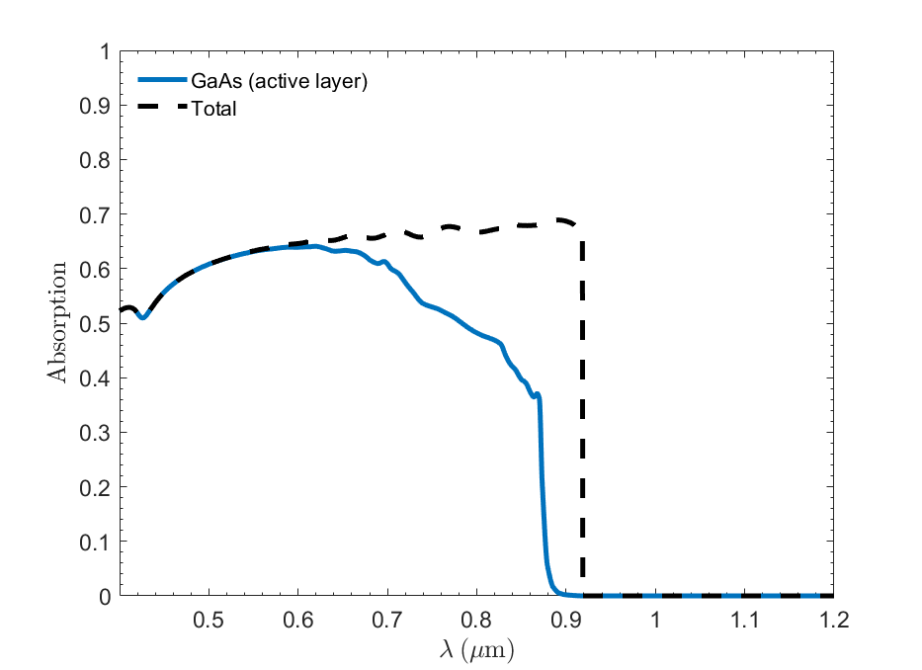
The range we are interested in (high-energy range):
 | Energy (eV) | Wavelength (nm) | Value of absorptivity
Lower bound | 1.50 | 827 | 0.459
Upper bound | 1.70 | 729 | 0.555

Example : total error on photon chemical potential $Δμ$:
$$Δ\left(Δμ\right)=\sqrt{{\left(Δ{\left(Δμ\right)}_{chi^{2}}\right)}^{2}+{\left(Δ{\left(Δμ\right)}_{range}\right)}^{2}+{\left(\frac{k_{B}T}{A_{0}}ΔA_{0}\right)}^{2}}$$

From excitation power to thermalized / cooling / thermal intensity
As an exercise for Oussama:
- write the detailed balance equation in terms of carrier number and energy (consider only non-radiative recombination first)
- relate the absorbed flux to the absorbed power, same for recombination
- relate the thermalized power to the absorbed power (and to finish, to the excitation power)
what changes if radiative recombination aren’t negligible?

Why do we need this relation?
To compare experiment and theory (see Tsai article), more exactly, the comparison point is
$$P_{th}(n,T)$$

Next step : simulate this function from the microscopic model developed is Tsai’s article (in order to compare with experiment)
Reminder : $d=950$ nm the thickness of the GaAs active layer
$A_{las}=0.625$ the absorptivity at the laser wavelength

25/02/2026 :
Tsai’s model does the following :
Tsai’s simulation
$Δμ, T$ ${\left(\frac{du}{dt}\right)}_{intra}=\frac{P_{th}}{d}$
(or $μ_{e}$ or $μ_{h}$ or $n$)

Carefull : here $P_{th}$ is an intensity (W/cm²) not a power ; dividing it by the thickness makes it a power density (per unit volume)

Take the experimental points ($Δμ, T)$and use the simulation to predict the corresponding value of $P_{th}$, and finally compare it to the experimental value actually we’ll do it the “other way around”

We take the experimental $Δμ$ and $P_{th}$, and predict with the simulation the value of $T$, and compare it to the experimental points.

Do the following:
- write in python file that computes ${\left(\frac{du}{dt}\right)}_{intra}$ compute the electron contribution only (we will discuss that next time)
- try it on a few values for $Δμ, T$, or $μ_{e}, T$ (but you know how to relate the µ’s)
- then, compute ${\left(\frac{du}{dt}\right)}_{intra}$ for “a lot of” $μ_{e}, T$ (continuous values) table, register it, reverse it to have $T(P_{th},μ_{e})$, interpolate the latter
- plot the experimental points with the simulated $T(P_{th},μ_{e})$ evaluated at the experimental points$(P_{th},μ_{e})$

